Shepherding Students’ Learning Styles in the Classroom - a Launch into the 21st Century
GRANT PROPOSAL
Magnolia School District, Magnolia, Mississippi
Sunday, June 28th, 2020

Amelia Watson
Luke Smith
Derrick Routon
Melissa Queen-Lomas

Project Title: Shepherding Students’ Learning Styles in the Classroom - a Launch into the 21st Century

Project Summary

This proposal addresses the challenges faced by teachers in our school district concerning appropriate and relevant instruction methodologies in keeping with our students’ various learning styles, a condition not well met under the current conditions and circumstances. The school district has declared an overarching objective to execute a program refocusing teacher instruction per various students’ learning styles in their classroom.

Introduction

The prerequisites for this objective included providing teachers age-appropriate instruments to collect the information needed to develop a profile of their students and provide a series of training workshops to help teachers interpret the results. As such, the expectations from these objectives are that teachers will be able to know their students precisely enough to create a learning environment and target instruction to meet their individual and collective needs.

Matthew Broome, superintendent of Magnolia School District, has encouraged teachers to work together to architect the ideal learning environment that will support individualized instruction that will meet diverse learner needs. The parameters for requesting up to $20,000 in funds to achieve this include the following: 1) a diagram of an ideal classroom-learning environment, 2) a list identifying and justifying all proposed acquisitions, and 3) a Dynamic Instruction Design (DID) model that develops an instructional design and sample plans that demonstrate full utilization of the ideal classroom.

This proposal illustrates this new model for the 21st Century Classroom that includes new technologies and equipment that will facilitate teaching techniques to augment all student-learning styles: visual, auditory, and kinesthetic. Furthermore, an instructional design and sample plans on the topic of Causes of the American Revolution for 5th grade Social Studies using the DID model will demonstrate the full utilization of the 21st Century classroom investment with metrics for evaluating its effectiveness and relevance.

The goal of the project is to take the teacher techniques and competencies gained from the workshop to assess students’ profiles and construct a model of instruction that addresses all student-learning styles: visual, auditory, and kinesthetic with the newly acquired set of equipment and technologies specifically chosen to fulfill those learning needs.

The need for the project is apparent in the current classroom landscape and outdated technologies that cannot cater to multiple student learning styles. In fact, the current stage of commodities only caters to visual learners, and excludes all others, including TAG and special needs students. The benefits derived from this 21st Century Classroom grant directly address the district’s objective to create an individual and collective environment for all learning styles by creating a holistic learning ecosystem for all types of students. For example, consider the current classroom diagram below:

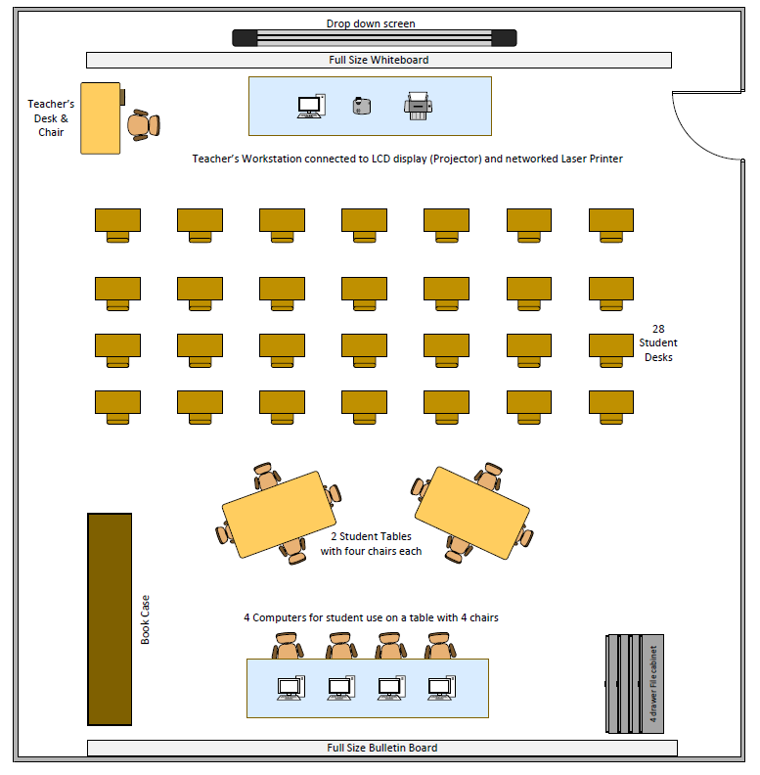
While physically accommodating the number of students involved, there is limited technology for each student to have at their disposal. Such limitations make opportunities for auditory and kinesthetic learning minimal and sequestered to a specific time-boxed allotment at the back of the room. The front-facing individual desks make student collaboration and learning from peers quite impractical. In this context, the teacher is made the main focus of the class by having their computer and projector as the prominent feature of the front of the class. This makes the teacher immovable during the lesson, leads to classroom management issues, and goes against best practices for diverse learners. Neither equipment nor technologies exist for those needing special accommodations, nor for those talented and gifted to be challenged beyond the scope of the lesson plans. Interaction and practice with technology is minimal to none; instead, it is a key tool reserved only for the teacher.

By contrast, the diagram below illustrates the utilization of procured assets to shepherd the evolutionary process of all student learning styles, particularly focusing on the elements that will help them learn and grow to be productive and competitive in the 21st Century. This exhibit addresses the first requirement of Superintendent Matthew Broome of the Magnolia School District.
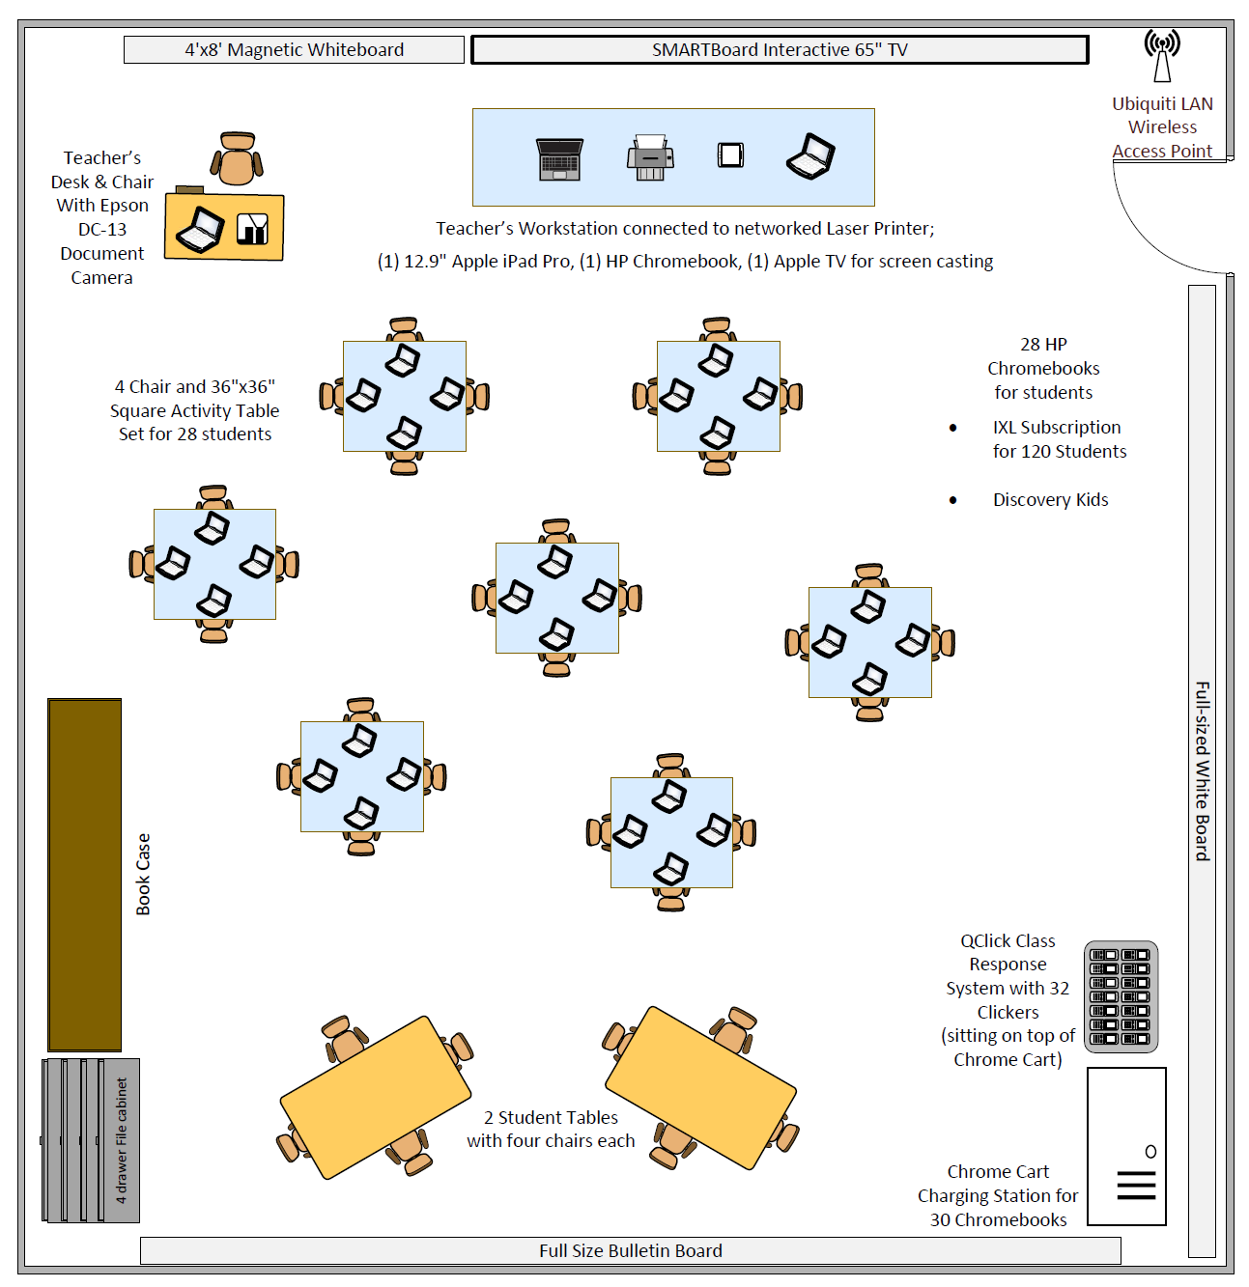

Project Budget

The second requirement in applying for the grant involved a list identifying and justifying all proposed acquisitions. If obtained, each of these new elements would be shared among other teachers as applicable for all students, including TAG and Special Needs. These assets would augment all students’ learning styles: visual, auditory, and kinesthetic. Below is a spreadsheet grid illustrating the fiscal breakdown.

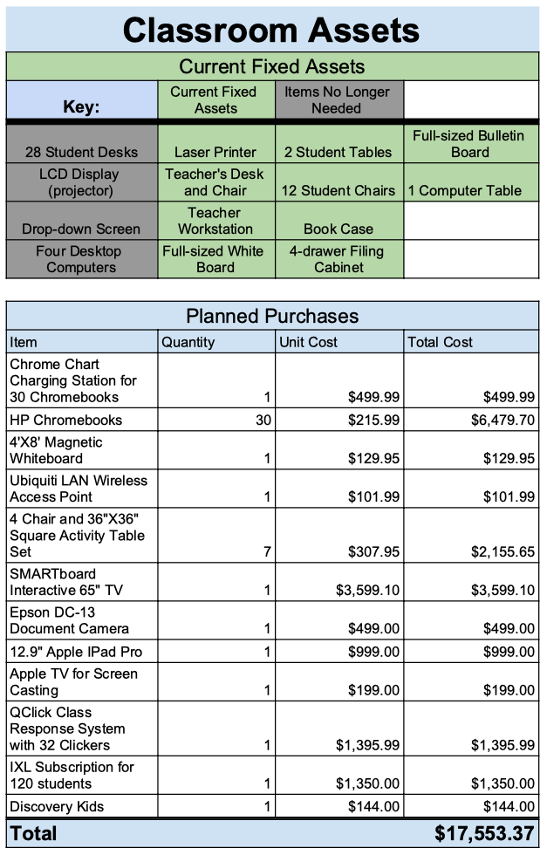
Budget Justification

With the classroom’s current assets, students will not have the opportunity to truly immerse themselves in an enriching technological environment. Proposed additions to the classroom will help students become confident in their usage of today’s technology and they will greatly improve the students’ ability to access and engage with digital content.

One of the most powerful classroom tools into today’s classrooms is computer access. Chromebooks are relatively inexpensive laptops that allow students to conduct research, work collaboratively, and access digital lessons quickly. Having enough Chromebooks in the classroom for every student to utilize at any time is crucial, as all students need consistent access to computers in order to develop their Internet and computer skills. It is also essential to purchase a charging cart for the Chromebooks, as this is the most efficient way to organize and charge the devices. Furthermore, the addition of a wireless access point in the classroom will give the teacher and students a strong Wi-Fi signal to ensure that the connection is consistent and fast.

The addition of a second whiteboard in the classroom will give the teacher the opportunity to better organize daily agendas, reminders, and information while also having the necessary space for drawing, modeling, and notetaking. Additionally, more whiteboard space creates more room for student collaboration on the whiteboard. Another technological element that will provide a great deal of utility and collaborative opportunity is the SMART board. SMART boards have a multitude of uses, such as basic projecting, writing notes on projected documents in real time, and playing educational games. In our day and age, a SMART board is truly a staple for every classroom.

To enhance the use of the SMART board, an Epson document camera will be incredibly helpful when displaying exemplary student work and when giving detailed instructions using a paper document. A document camera is truly an invaluable tool when attempting to show the whole class how to do an assignment on paper in real time. Similarly, the use of an Apple iPad Pro will allow the teacher to write on digital slides and documents in real time. Pairing the iPad with Apple TV will give the teacher the ability to seamlessly cast their screen onto the SMART board, which will serve as an excellent way to preview texts, images, and documents of all mediums with students.

When it comes to student collaboration, working at tables is far more conducive to effective communication and simple grouping than working at desks. As a result, the purchase of tables and chairs for all students in the classroom to utilize on a daily basis will promote smooth transitions into group work. Furthermore, having new, sturdy tables truly makes a difference when it comes to preventing distracting noise during lessons. From their tables, students can utilize their QClickers to respond to prompts on teacher presentations. Having students use clickers allows teachers to quickly collect tangible formative data on how well students understand the lesson. Additionally, the use of clickers encourages students to remain engaged as they anticipate the need to respond to upcoming questions.

IXL is a software that will help our students work on every subject area on their level. Students can work on whichever grade level that is appropriate for them. IXL provides students who might be behind in certain areas to have extra practice on their grade level. This will help with lower-performing students who might need some remediation, and it will provide additional grade level practice for students who are on grade level. Discovery Kids is a digital library full of immersive, engaging texts and activities for students to read and interact. This is a program that is well received by 5th grade students, and it can be used by students who have finished lessons early, or can be used by teachers to assign specific lessons and content to their students.

Utilization of the 21st Century Classroom: Instructional Design and Sample Plans

The third and final requirement of superintendent Broome in applying for the grant was to provide instructional design and sample plans using the DID model. The following exhibits the integration of the proposed equipment and technologies, as it would be employed in the new classroom.
Causes of the American Revolution
5th Grade Social Studies

Know the Learner:

This 5th grade social studies class of 28 students has the following racial makeup: 61% white, 21% Hispanic, and 15% black. All six of the Hispanic students are English language learners, but their academic performance is similar to that of their peers. Benchmark testing indicates that most students are capable of reading on grade level, but there are four who read below grade level, and ten who read above grade level. The class contains four gifted students and two dyslexic students, but none of the students has 504 plans or IEPs. Most of the students in the class aim to succeed in social studies, and they enjoy learning about wars and controversy.

Objectives:

The students will be able to:
- Identify at least three causes of the American Revolution. (DOK 1)
- Construct a visual representation of one cause of the American Revolution. (DOK 3)

Standards:
2016 Mississippi College- and Career-Readiness Standards for Social Studies
- H 5.5 – Chart the causes and events leading to the American Revolution. Cite the reasons for the establishment of early colonies in North America.
o H 5.5.2 – Describe the colonial reaction to the British Stamp Act, Intolerable Acts, Boston Massacre, and Tea Act.

Teaching and Learning Strategies:
Teaching Strategies:

- Word Wall - Before the lesson begins, the teacher asks the students: “What do you know about the American Revolution and the Boston Tea Party?” The teacher will then use the whiteboard to create a word wall that will be displayed throughout the lesson.

-Video Topic Introduction - The teacher will begin the lesson by playing an American Revolution and Boston Tea Party themed rap cartoon video on the SMART board. The video is four minutes long, and the teacher will give a brief introduction to the video. Students will be able to listen to the video as a whole class and closed captions will be turned on. The teacher will briefly connect the rap to the day’s lesson.

- Teacher Modeling - The teacher will inform students that they will be reading a text about seven causes that led to the start of the American Revolution. The teacher will display the digital text on the SMART board and will model scanning over the text. The modeling will include the teacher highlighting key words within the text on an iPad, and casting it to the SMART board via an Apple TV adapter so students can see the key words and their locations within the text. Students will be instructed to read the text independently.

- Live Polling/Questioning - Throughout the lesson, the teacher will ask formative assessment questions. Students will be presented with multiple choice questions and use the QClickers to select their response. Live polling will be displayed so that the teacher, as well as the students, may see how well the content of the lesson is being retained.

- Presenting Sample Work - The teacher will inform students that they will be sorted into groups to create either Google Slides or a poster after they finish reading. The teacher will use the SMART board to display example work. They will show a sample poster using the document camera, and they will also show a sample slideshow. Students who complete the presentation via Google Slides will email a link to the teacher and have their work displayed on the SMART board. Students who choose to create a poster will utilize the document camera and display their work on the SMART board.

Learning Strategies:

- Active Independent Reading - Students will independently read the text about the causes of the American Revolution. This can be done on paper or using a Chromebook. As students read, they should highlight key details, annotate the passage, and take notes on scratch paper.

- Group Project Production - Students will be divided into seven groups to create Google Slides or a poster detailing one of the reasons for the start of the American Revolution. Groups will be numbered one through seven, and the group number will correspond with the topic each group is to cover in their project. Each group will decide if they want to use Google Slides or a poster to represent the information. The teacher may have to step in to help students work collaboratively to make this decision. Students will use facts from their section of the article to create their project. The slides and posters will be turned in to the teacher at the conclusion of the class period.
- Early Finisher Work – Those who finish early may review their work or perform enrichment activities on the Discovery Kids website. Additionally, there is an enrichment assignment on the Boston Tea Party that was created in IXL.

Technologies and Materials:
- Chromebooks (one for each student)
- SMART board and whiteboard
- Epson document camera
- QClick clickers (one for each student)
- Digital and print copies of text
- Pencils, highlighters, colored pencils, markers
- Scratch paper
- Poster paper
- American Revolution Text – history.com
- American Revolution/Boston Tea Party Rap: Schoolyard Rap on YouTube

Evaluation and Revision:

Student knowledge will be assessed based on the ability to name a minimum of three causes of the American Revolution and the ability to produce a factually accurate visual representation of one of said causes.
- If more than 15% of students cannot correctly name at least three causes of the American Revolution, the teacher will review the material with the students again the following day.
- If any group does not finish their group project by the end of class, they will be given the opportunity to finish after school or during class time later in the week.
- If any group creates a slideshow or poster that contains inaccurate information, the teacher will work with the group to dispel false information and allow students the time to correct the mistakes.

Project Timelines

For this project, the timeline will be short. All purchases will be made simultaneously. When they arrive, our technology team will need a two-day period to label and tag all acquisitions with fixed asset codes. Additionally, there will be some initial set up time for the Chromebooks, as they will need to be modified to our school’s networking criterion. Moreover, our technology team will be performing three professional development sessions to train teachers in the use of the newly acquired technologies. These professional development sessions will be performed in three, two-hour-long sessions after school.
From purchase to in-classroom use, the project timeline will be as follows:
- Three weeks for acquisition purchases and delivery.
- Two days of device registry, fixed asset tagging, setup, networking, and installation.
- Three days of professional development training with the school’s technology team.
- One week for lesson plan adaptation to incorporate new classroom technologies.

Project Personnel

The project personnel responsible for implementing the grant and having oversight of the objectives will be the lead teachers for 5th grade Social Studies. They have Master Degrees in Human Capital Development, have ten years’ of teaching experience between them, and have nearly 100% time allocation to utilization of the 21st Century Classroom technology and equipment to achieve these district goals and objectives.

Evaluation of Project Results

The goal for our classroom is to create an environment where every student has a chance to learn, regardless of his or her learning style. If we are able to create this classroom, a direct result will be higher student success academically. In order to evaluate if we achieved this goal, we will administer a diagnostic style assessment at the start of the year, during the middle of the year, and at the end of the year. We expect to see growth across the board on all three of these assessments for our students. We will compare these results to previous years to see if our students grew more this year than they have in the past. We will also compare these results with the results of other classes to see if our students grew more than those in classrooms that do not have similar technology. If our classroom setup is successful, our students should see higher growth than those in regular classrooms.

Summary

In conclusion, we teachers representing 5th grade Social Studies in the Magnolia School District request our grant proposal be awarded on the grounds of alignment with the district’s goals and objectives of refocusing teacher instruction per various students’ learning styles in their classroom. Our proposal and artifacts substantiate the collective effort to apply opportunities afforded from new equipment and technology to contribute to all students’ learning styles and for all types of students. Evaluation of student performance will demonstrate the benefits of this investment while also promoting the path for others.

Thank you for your time and consideration of our grant proposal.
Amelia Watson
Luke Smith
Derrick Routon
Melissa Queen-Lomas

